ONLINE RETAIL AND NETFLIX DATASET - Cleaning Summary
- DATA UNDERSTANDING
Number of Rows: 541909
Number of Columns:8
Numerical columns: Quantity, Unit price
Categorical columns; invoiceNo, stockcode, description, Invoice date, Country, customer_ID
Primary key: Invoice No

The online Retail Dataset contains a transactional sales information from a UK-based online retailer. It includes information about products purchased, quantities sold, prices, customers, transactional sales information from a UK-based online retailer invoice dates and countries.

NETFLIX DATASET
Number of Rows: 8807
Number of Columns:12
Numerical columns: release year
Categorical columns; Type, title, director, cast, country, rating, duration, listed in, description
Primary key: Show_id

The Netflix dataset contains information about movies and television shows available on Netflix. It includes details such the title, movie type, director, cast, country of production, release year, content rating, duration, genres, and the date content was added to Netflix.

- DATA CLEANING DOCUMENTATION
Columns with missing values; customer_id, description, unit price
Customer_id had 135080 missing values
Description column had 1454 missing values
Unit price had 2 missing values
Missing value was removed from customer_id because customer analysis required a valid IDS

5268 Duplicates were removed

NETFLIX
Columns with missing values; Director, country, rating, date added, duration, cast
Director had 2634 missing values
Country column had 831 missing values
Rating had 4 missing values
Date added had 98
Duration had 3 missing values
Cast had 825 missing values
Missing values were replaced with unknown to avoid data loss
No duplicate found

Issues found | Action taken
Missing values | Removed
Duplicates | Removed
Negative values | Kept as returned
Standardization | Applied

NETFLIX SUMMARY
Issues found | Action taken
Missing values | Replaced
Standardization | Applied

STANDARDIZATION
Text formatting to upper in description and country
Unit price data type was changed from float to decimal
Trimmed spaces

NETFLIX
Text formatting to upper in title, director, type, rating, cast and country

- EDA 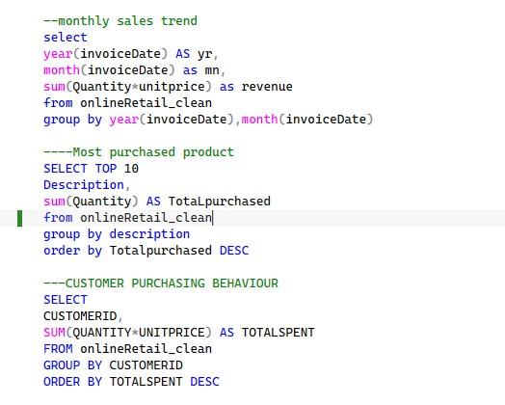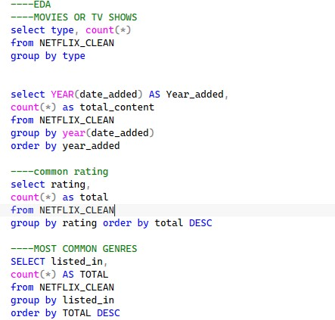
- INSIGHTS
- The UK contribute majority of the sales
- The month November generates highest revenue
- A small number of products generate a large share of revenue

NETFLIX
- Movies significantly outnumber TV shows on Netflix
- The United States is the largest producer on Netflix
- TV-MA and TV-14 are the most common ratings

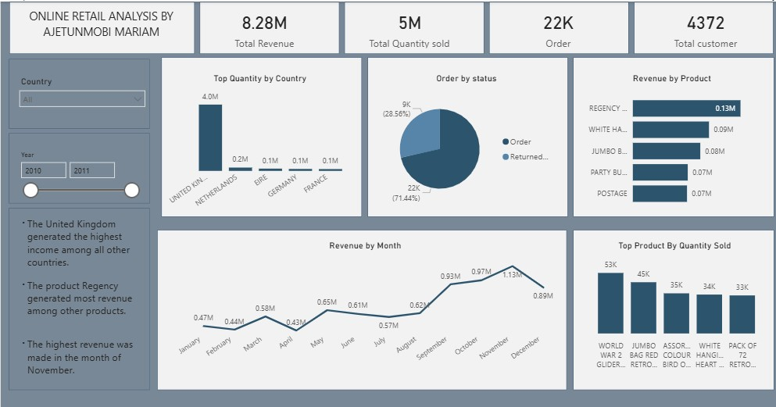

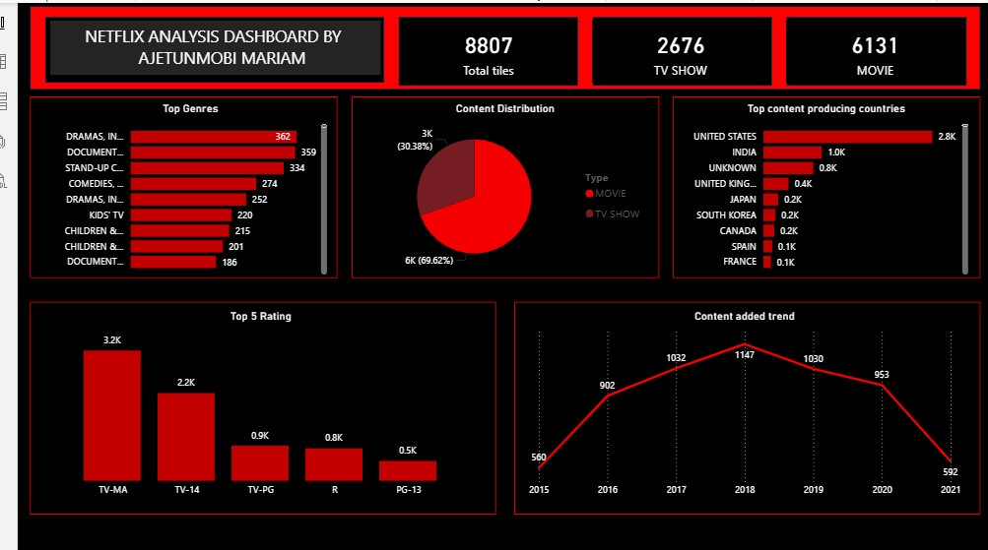

DATA CLEANING AND EXPLORATORY DATA ANALYSIS OF ONLINE RETAIL AND NETFLIX DATASETS
Project overview
This project focused on cleaning, validating, and analysing two datasets Online retail and Netflix datasets. The goal was to improve the quality of data, prepare the datasets for analysis, uncover meaningful patterns through exploratory data analysis and visualization.
- Cleaning challenges encountered
- Missing values were found in the customer id and description columns
- Duplicate transactions records existed
- Incorrect data type
- Negative quantities were observed, representing returned or cancelled orders
- Trimmed spaces

NETFLIX
- Missing values were present in the director, cast, country, rating, date added and duration columns
- Text formatting inconsistencies
- EDA FINDINGS
- The United Kingdom generated the highest revenue contributing the majority of the sales
- A few products accounted for a large percentage of sales
- Monthly Sales analysis revealed seasonal fluctuations and periods of purchasing activity
- More orders were placed more than some which shows purchasing behaviour
NETFLIX
- Movies represented a larger share on Netflix content compared to TV show
- The United States emerged as the leading producer of content
- Content addition increased steadily over time occurring in the years

- KEY INSIGHTS
- The United Kingdom serves as the retailer’s primary market, generating the highest revenue
- Sales patterns varied across different periods suggesting seasonal trends that could influence decision making
- A small number of products generated a large share of total revenue

NETFLIX
- Movies make up the majority of the Netflix’s library outnumbering TV shows
- The amount of content added to Netflix increased over the years, highlighting the platform’s continuous growth
- Rating such as TV-MA and TV-14 appeared most frequently indicating that mature audiences are their target audience

CONCLUSION
The cleaning process improved the accuracy, consistency of both datasets. The exploratory analysis revealed valuable business insights including revenue concentration, customer purchasing behaviour, content distribution and country level contributions.

